GREEN COMPUTING RESEARCH PROJECT

TEAM NAME: PEPPERMINT

Team members: Lidia rodionova, nikola petrovski, wassim shamass

15 APR 2018

PROFESSOR: richard yanaky

class day/time: mondays 1pm

**Check List**

Appropriate cover page

Completed Check list page

Project Charter (Part 1, Task 1)

Scope Statement (Part 2, Task 1)

WBS – List Form (Part 2, Task 2)

Gantt chart (Part 2, Task 3)

SMART paper (Part 3, Task 1)

Milestone Report (Part 3, Task 2)

Gantt chart (Part 4, Task 1)

Cost estimate (Part 4, Task 2 revised version)

Report elements sequenced as required.

Microsoft Project file.

Table of Contents

Part 1: Project Integration Management 4

Project Charter 4

Part 2: Project Scope Management 7

Scope Statement 7

WBS – List Form 10

WBS – List Form (continued) 11

Gantt chart 12

Gantt chart (continued) 13

Part 3: Project Time Management 14

SMART paper Identifying Milestones for Green Computing Research Project 14

Gantt chart 15

Part 4: Project Cost Management 17

Cost estimate 17

Cost estimate (continued) 18

Cost estimate (continued) 19

Appendix: Included .mpp file 20

Microsoft Project file 20

# Part 1: Project Integration Management

## Project Charter

|  |  |
| --- | --- |
| **Project Title**: Green Computing Research  **Project Start Date**: March 26, 2018 | **Project Finish Date**: September 26, 2018 |
| **Budget Information**: $500,000 | |
| **Project Manager**: Nikola Petrovski, Lidia Rodionova, Wassim Shamass | |
| **Project Objectives**: Create a Green Computing Research Report that will describe the ways that We Are Big Inc. can help improve the environment while increasing revenues and reducing costs. The project will research ways to improve energy efficiency in the data centre and overall throughout We Are Big offices. Report will also feature ways to reduce electronic waste, especially through researching electronics recycling, researching a global telecommuting strategy for all employees including switching to a thin computing model and virtualization of server resources. The report will also describe the feasibility of open source alternatives to paid software for internal use. | |
| **Main Project Success Criterion**: Project meets schedule and budget requirements. | |
| **Approach**:   * Investigate which green features are feasible for We Are Big Inc. * Analyze internal and external sources and examples of similar projects. * Evaluate hardware and software needs and ways to improve energy efficiency. * Research ways to minimize electronic waste. * Research telecommuting options for We Are Big employees, * Research server virtualization * Research implementing thin client solutions and open source options. * Solicit user feedback. * Find a method to measure the value of proposed new improvements in terms of reduced costs and possibility of new revenues. | |

Project Charter (continued)

|  |  |  |  |
| --- | --- | --- | --- |
| Roles and Responsibilities: | | | |
| **Name:** | **Role:** | **Position:** | **Contact Information:** |
| Natalie | Program Sponsor | VP of Operations | natalie@wearebig.com |
| Ito | Program Manager | Manager | ito@wearebig.com |
| Steering Committee:  1. Natalie  2. Ben  3. Jake  4. Neil  5. Pete  6. Ann  7. Lara  8. Nina  9. Tom  10. May | Committee Member | Committee Member | 1. natalie@wearebig.com  2. ben@wearebig.com  3. jake@wearebig.com  4. neil@wearebig.com  5. pete@wearebig.com  6. ann@wearebig.com  7. lara@wearebig.com  8. nina@wearebig.com  9. tom@wearebig.com  10. may@wearebig.com |
| Ben | Project Sponsor | CIO | ben@wearebig.com |
| Walinik | Project Manager | Manager | walinik@wearebig.com |
| Matt | Senior Technical Specialist, expert in collaboration technologies, volunteer to dispose of old electronics | Researcher | matt@wearebig.com |
| Teresa | Systems Analyst in IT Department, expert in virtualization | Researcher | teresa@wearebig.com |
| James | Senior consultant in strategic research department, excellent presenter | Researcher | carol@wearebig.com |
| Le | Wrote doctoral thesis on green computing | Researcher | le@wearebig.com |
| Deb | Part time editor and consultant | Editor | deb@wearebig.com |

Project Charter (continued)

Signatures:

[Natalie’s Signature]

[Ito’s Signature]

[Ben’s Signature.]

[Walinik’s Signature]

Comments:

“Our company is committed to reducing our carbon footprint. This project is the first step to a cleaner, greener We Are Big Inc.” ~Natalie, VP Operations

“We need to make sure that IT Performance is not affected by the new energy efficiencies.” ~Ben

# Part 2: Project Scope Management

## Scope Statement

**Project Title**: Green Computing Research

**Date**: April 2, 2018

**Prepared by**: Walinik, Project Manager

**Email**: walinik@wearebig.com

**Project Summary and Justification:**

Ben, CIO of We Are Big Inc., requested this project to assist the company in meeting its strategic goals.

The reports developed through this research project will improve the company’s environment

and financial status by implementing new software for internal use and potential sale to external clients.

It will also help reduce waste and increase revenue by providing standard practices, methods, processes, guidelines, and project management knowledge to all people working inside the company. The budget for the project is $500,000. There are no additional operational expenses required after the project is completed. Estimated costs of $300,000 are for internal stuffing and the rest will go to outside sources. It is important to focus on the system's costs and benefits to be able to make an informed decision.

Scope Statement (continued)

**Product Characteristics and Requirements:**

1. Data center technology and energy efficiency: People will use computer systems and associated components, such as telecommunications and storage systems. The new system will allow internal users to work with more energy-efficient information and communication technologies (ICT) equipment and systems. For example, videoconferencing and telework using ICT can reduce carbon dioxide emissions by reducing the need to commute to work, creating a paperless work environment, and promoting more efficient use of office space.

2. Electronic waste management: Users will be encouraged to apply advanced waste treatment technologies or sophisticated waste management services, collection and recycling equipment.

3. Telecommunication technology: The use of state-of the-art telecommunication equipment, innovative and new services such as Wireless Data Applications and E-Business applications will support business operations.

4. Virtualization of server resources: Power consumption monitoring equipment, server virtualization/consolidation and Software as a Service (SaaS) are considered primary green IT solutions.

5. Thin client solutions technology: A thin client is a lightweight computer that has been optimized for remoting into a server-based computing environment. The server does most of the work, which can include launching software programs, crunching numbers, and storing data. In contrast, a conventional desktop PC (fat client) typically performs the same tasks locally, but can also remote into a server-based environment when needed.

6. Use of open source software: growing interest in open source. with its source code made available with a license in which the copyright holder provides the rights to study, change, and distribute the software to anyone and for any purpose. Open-source software may be developed in a collaborative public manner.

7. Development of new software for green computing: In addition to increasing supply of data centers, the data centers are becoming more energy efficient. Green datacenter strategy and new energy-efficient tools will not compromise their actual facilities.

Scope Statement (continued)

**Summary of Project Deliverables:**

Project Management Related Deliverables:

Project charter, Scope statement, Work breakdown structure, Microsoft Project file that includes a Gantt chart and at lease 4 milestones, SMART paper, Milestone report, Cost estimate, Lessons Learned Document.

**Product Related Deliverables:**

1. Data Centre and Energy Efficiency Report

2. Disposal of Electronic Waste Report

3. Telecommuting Report

4. Server Virtualization Report

5. Thin Client Solutions Report

6. Open Source Software Report

7. Development of Internal Software Report

8. Final Report that is composed of the combination of information from all other reports.

9. At list of at least 20 different green project ideas.

10. A list of 4 recommended projects: based on analysis of 20 different ideas.

**Project Success Criteria:**

Our goal is to complete this project in six months for no more than $500,000. The project must include reports listed in the list of deliverables in the above section and must include a list of four project ideas for We Are Big Inc. that can be implemented.

## WBS – List Form

Task Name

**Green Computing Research Project**

1. **Manage Project**
   1. Select Project Team
   2. Coordinate with Environmental Technologies Program
2. **Create Data Centre and Energy Efficiency Report**
   1. Research report
   2. Write report
   3. Edit report
   4. Get Project Manager Approval
   5. Publish report
   6. Data Centre and Energy Efficiency Report Published
3. **Create Disposal of Electronic Waste Report**
   1. Research report
   2. Write report
   3. Edit report
   4. Get Project Manager Approval
   5. Publish report
   6. Disposal of Electronic Waste Report Published
4. **Create Telecommuting Report**
   1. Research report
   2. Write report
   3. Edit report
   4. Get Project Manager Approval
   5. Publish report
   6. Telecommuting Report Published
5. **Create Server Virtualization Report**
   1. Research report
   2. Write report
   3. Edit report
   4. Get Project Manager Approval
   5. Publish report
   6. Server Virtualization Report Published
6. **Create Thin Client Solutions Report**
   1. Research report
   2. Write report
   3. Edit report
   4. Get Project Manager Approval
   5. Publish report
   6. Thin Client Solutions Report Published

## WBS – List Form (continued)

1. **Create Open Source Software Report**
   1. Research report
   2. Write report
   3. Edit report
   4. Get Project Manager Approval
   5. Publish report
   6. Open Source Software Report Published
2. **Create Development of Internal Software Report**
   1. Research report
   2. Write report
   3. Edit report
   4. Get Project Manager Approval
   5. Publish report
   6. Development of Internal Software Report Published
3. **Recommend four projects for implementation**
   1. Compile list of 20 project ideas
   2. Research feasibility, cost and benefits for all 20 items on the list
   3. Narrow down list to four potential projects
   4. Submit final list of four potential projects to management
   5. Final list of four potential projects submitted to management

## Gantt chart

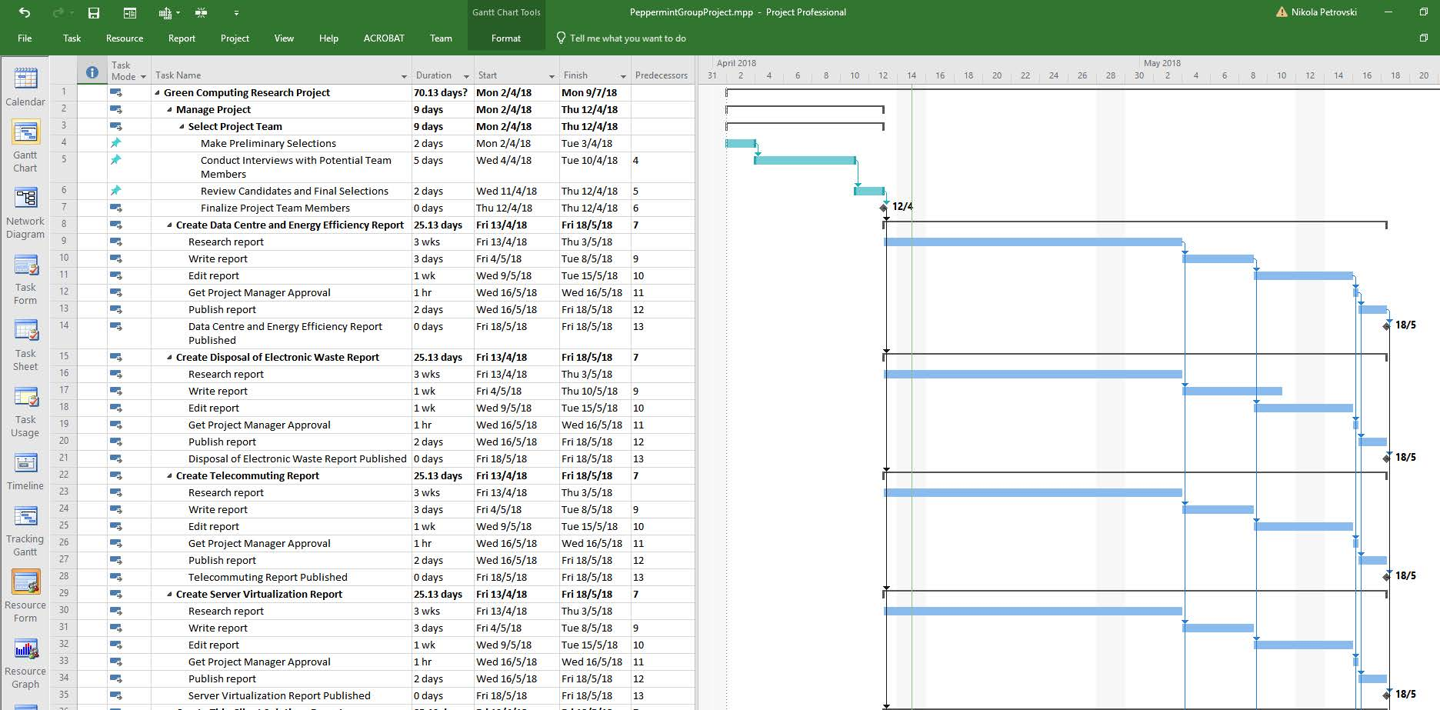

## Gantt chart (continued)

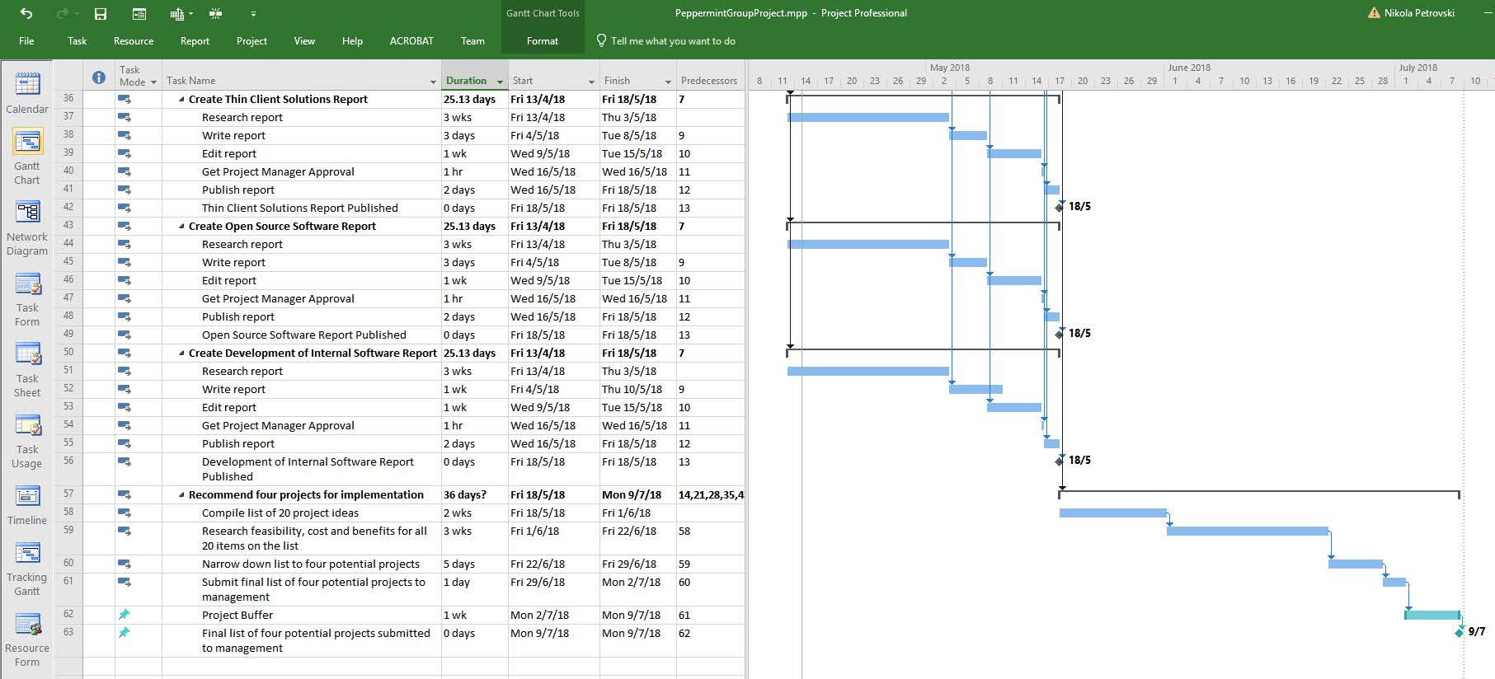

# Part 3: Project Time Management

## SMART paper Identifying Milestones for Green Computing Research Project

|  |  |
| --- | --- |
| Milestone: | Description: |
| 1. Select Project Team | • Preliminary Selections / finalize project team members  • Conduct interviews with potential team members  • Review candidates and make final selections  • Time-framed from 2/4/2018 to 12/4/2018. |
| 1. Publishing a Data Centre and an Energy Efficiency Report | • Specific to Data Centre and Energy Efficiency;  • Measurable by preparing and issuing a copy to Ben;  • Assignable to Teresa;  • Realistic because it is an achievable event;  • Time-framed from 13/4/2018 to 18/5/2018. |
| 1. Publishing an Electronic Waste Report | • Specific to Electronic Waste;  • Measurable by preparing and issuing a copy to Ben;  • Assignable to Matt;  • Realistic because it is an achievable event;  • Time- framed from 13/4/2018 to 18/5/2018. |
| 1. Publishing a Telecommuting Report | • Specific to Telecommuting;  • Measurable by preparing and issuing a copy to Ben;  • Assignable to Matt;  • Realistic because it is an achievable event;  •Time- framed from 13/4/2018 to 18/5/2018. |
| 1. Publishing a Server Virtualization Report | • Specific to Server Virtualization;  • Measurable by preparing and issuing a copy to Ben;  • Assignable to Teresa;  • Realistic because it is an achievable event;  • Time- framed from 13/4/2018 to 18/5/2018. |
| 1. Publishing a Thin Client Solutions Report | • Specific to Thin Client Solutions;  • Measurable by preparing and issuing a copy to Ben;  • Assignable to Le;  • Realistic because it is an achievable event;  •Time- framed from 13/4/2018 to 18/5/2018. |
| 1. Publishing an Open Source Software Report | • Specific to Open Source Software;  • Measurable by preparing and issuing a copy to Ben;  • Assignable to James;  • Realistic because it is an achievable event;  •Time- framed from 13/4/2018 to 18/5/2018. |
| 1. Publishing a Development of Internal Software Report | • Specific to Development of Internal Software;  • Measurable by preparing and issuing a copy to Ben;  • Assignable to James;  • Realistic because it is an achievable event;  •Time- framed from 13/4/2018 to 18/5/2018. |
| 1. Submitting a Final List of Four Potential Projects to Management | • Specific to Final 4 Projects  • Measurable by preparing and issuing a copy to Ben;  • Assignable to Le;  • Realistic because it is an achievable event;  • Time- framed from 18/5/2018 to 9/7/2018. |

## Gantt Chart

### Project Management

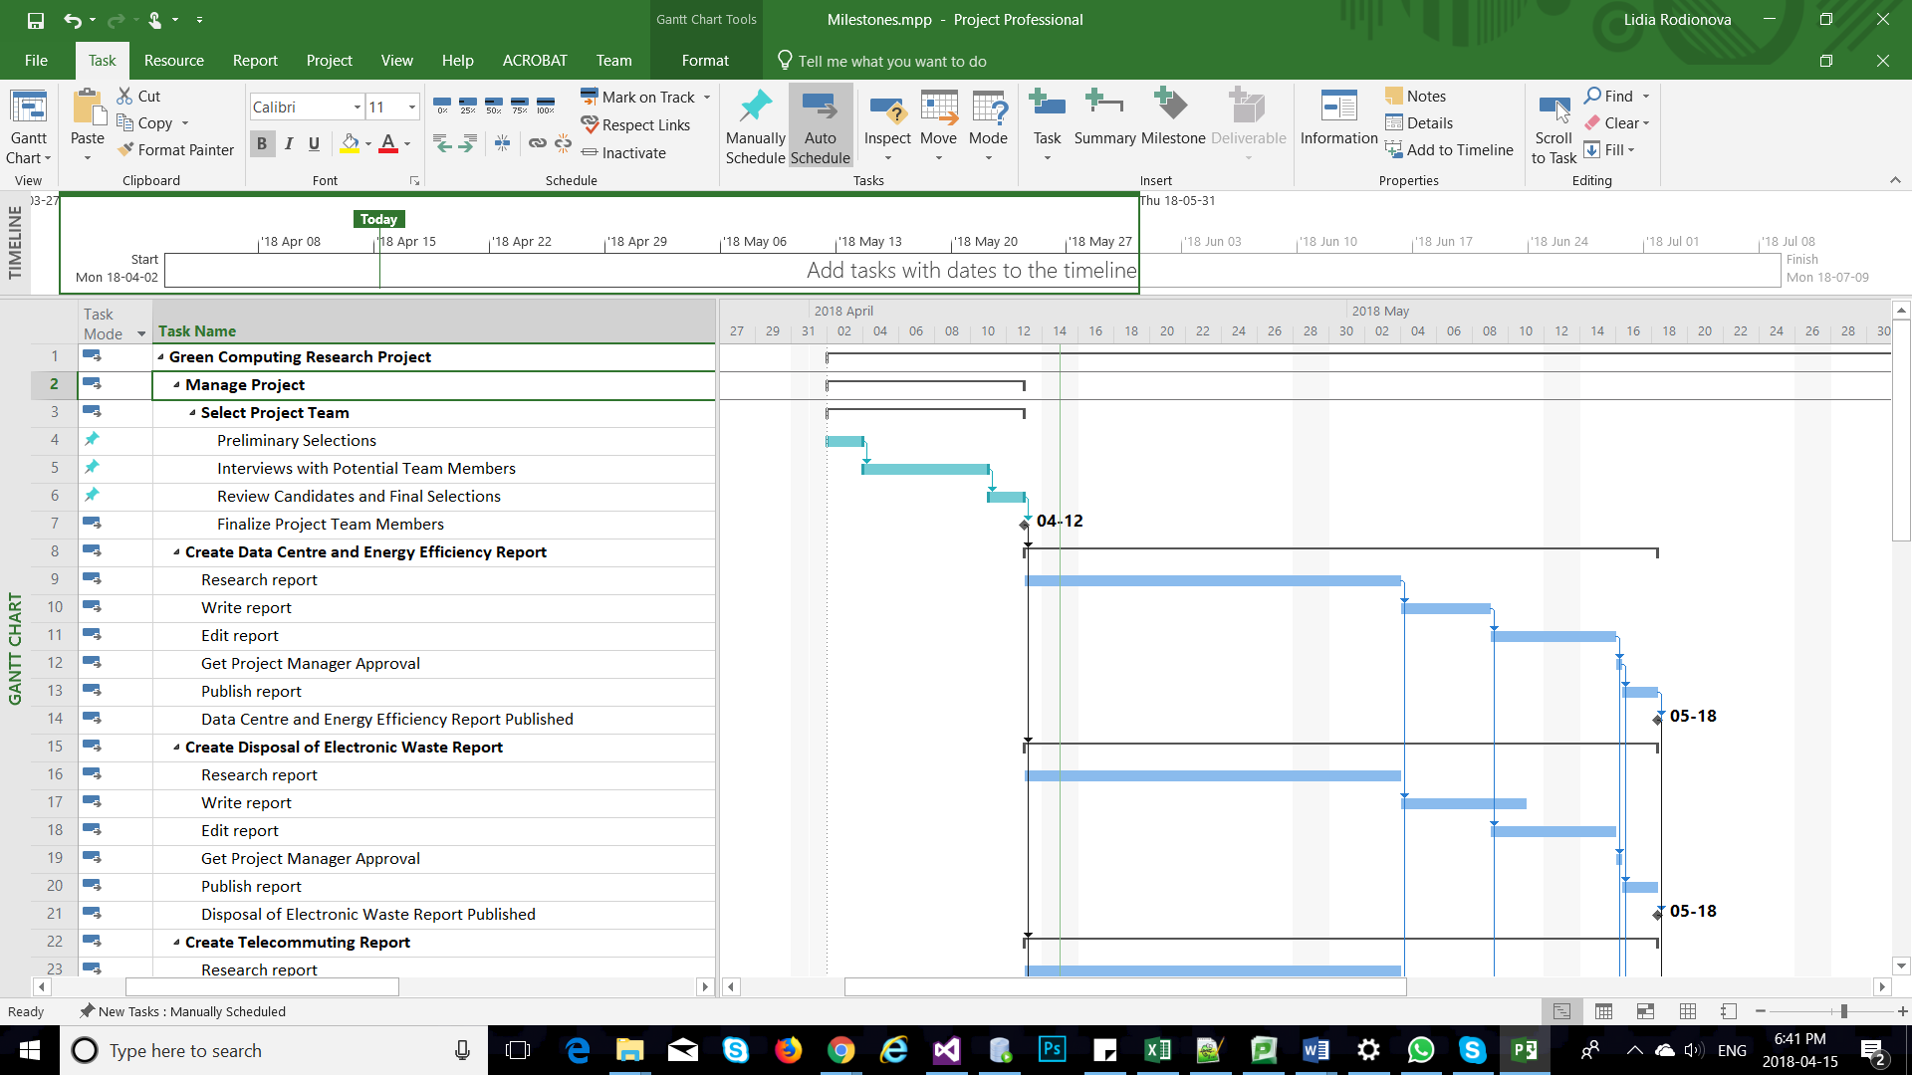

### Data Centre and Energy Efficiency Report

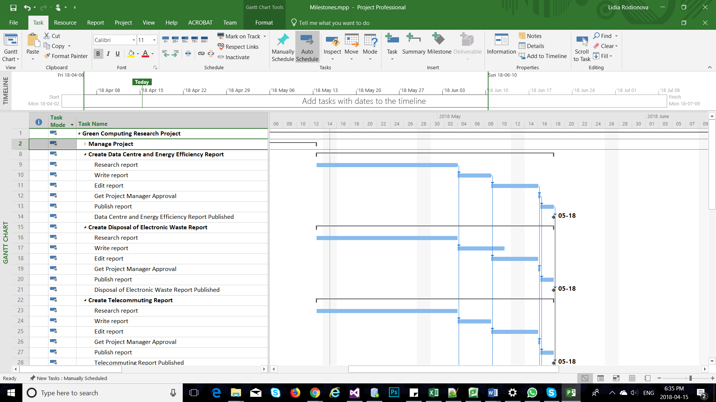

### Disposal of Electronic Waste Report



### Telecommuting Report

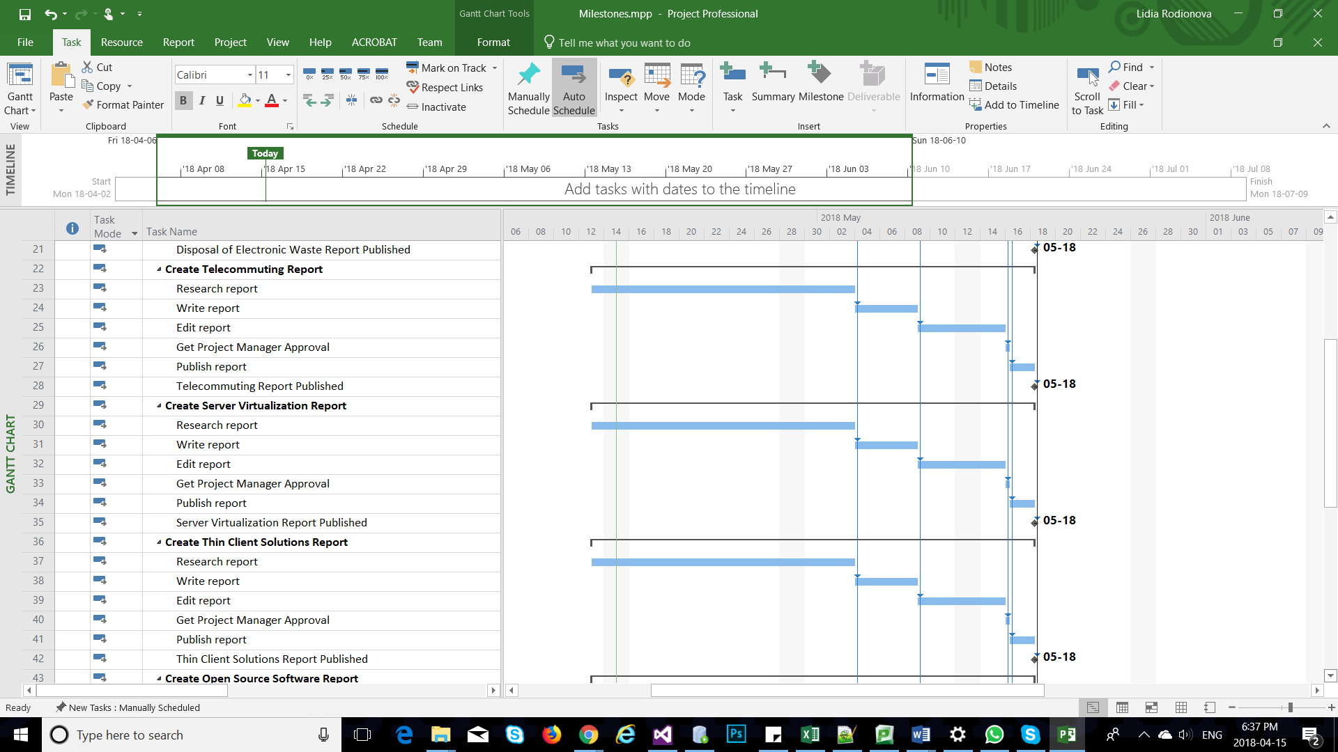

### Create Thin Client Solutions Report



## Gantt Chart (continued)

### Open Source Software Report

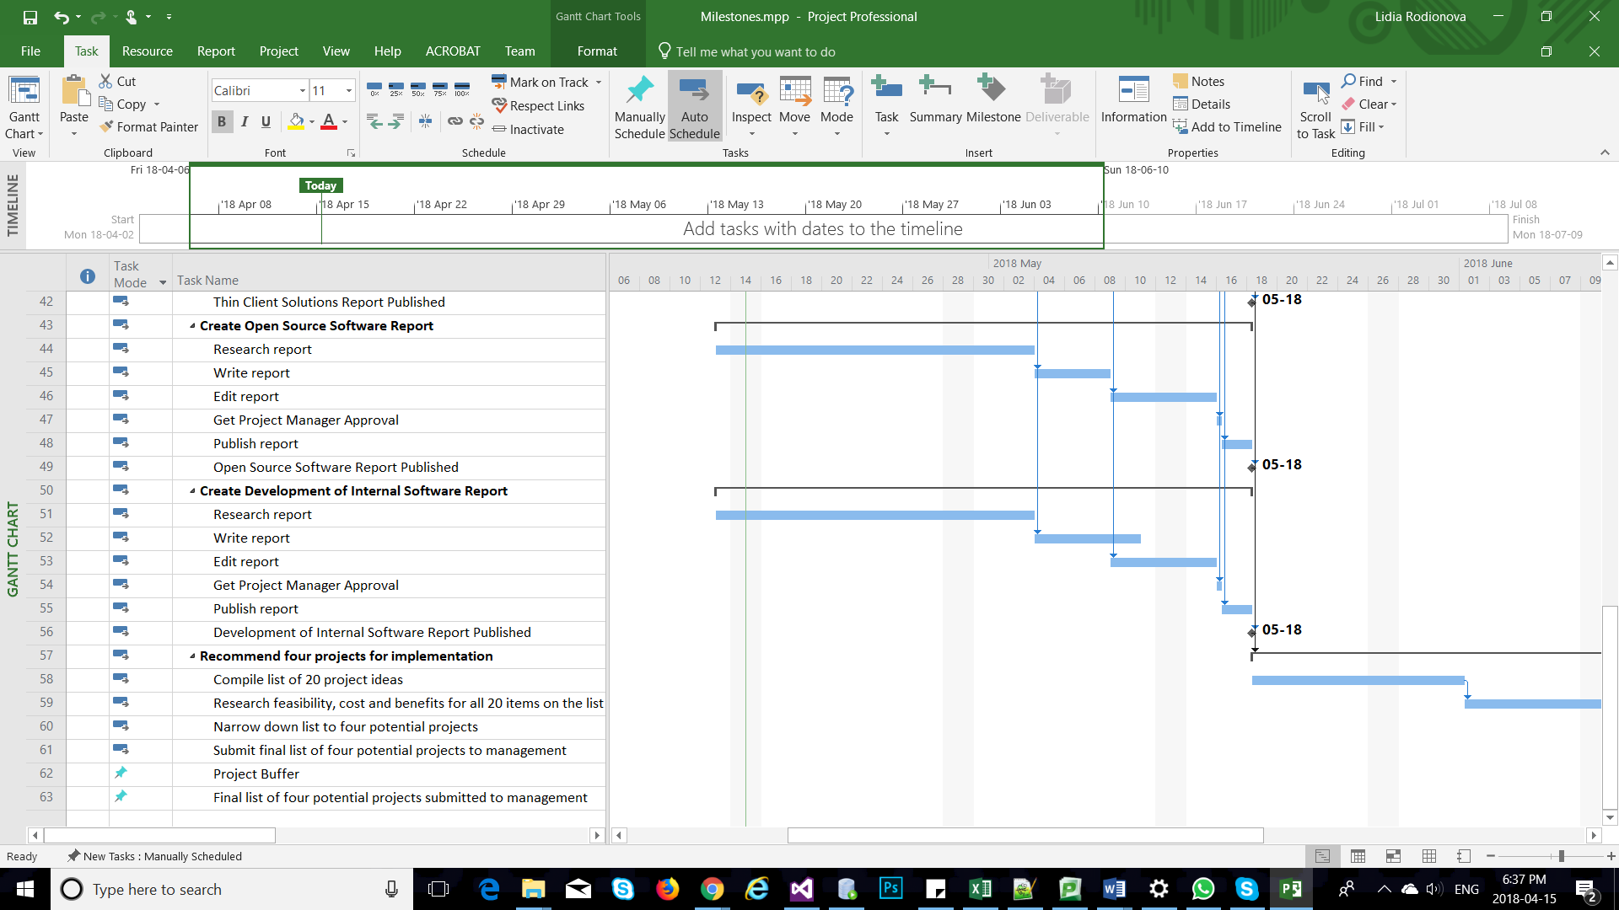

Create Development of Internal Software Report

### Recommend Projects for Implementation

# Part 4: Project Cost Management

## Cost estimate

Green Computing Research Project Cost Estimate Created April 14

|  |  |  |  |  |  |
| --- | --- | --- | --- | --- | --- |
|  | # Units/Hrs. | Cost/Unit/Hr. | Subtotals | WBS Level 2 Totals | % of Total |
| WBS Items |  |  |  |  |  |
| **1. Project Management** |  |  |  | **$ 32,000** | **15%** |
| Project manager | 320 | $ 100 | $ 32,000 |  |  |
| **2. Reports** |  |  |  | **$ 61,600** | **27%** |
| 2.1 Internal Writers* |  |  | $ 61,600 |  |  |
| **3. Editing and Consulting** |  |  |  | **$ 34,000** | **15%** |
| 3.1 Part-time Editor | 140 | $ 200 | $28,000 |  |  |
| 3.2 Travel Cost |  |  | $ 6,000 |  |  |
| **4. Reserves (20% of total estimate)** |  |  |  | **$ 100,000** | **43%** |
| **Total project cost estimate** |  |  |  | **$ 227,600** |  |

* See reports writing estimate.

Green Computing Research Reports Generation Estimate Created April 14

|  |  |  |  |  |
| --- | --- | --- | --- | --- |
| **1. Labor Estimate** | # Units/Hrs. | Cost/Unit/Hr. | Subtotals | **Calculations** |
| Teresa | 176 | $ 90 | $ 15,840 | 176*90 |
| James | 176 | $ 90 | $ 15,840 | 176*90 |
| Lee | 176 | $ 90 | $ 15,840 | 176*90 |
| Matt | 176 | $ 80 | $ 14,080 | 176*80 |
| **Total labor estimate** |  |  | **$ 61,600** | Sum above four values |

## Cost estimate (continued)

Given the following information for the first three-months of the project, the calculated earned value provides valuable costs control information about work performance, cost forecast, and required changes and project updates.

* PV=$160,000
* EV=$150,000
* AC=$180,000
* BAC=$500,000

2.a. The cost variance, schedule variance, cost performance index (CPI), and schedule performance index (SPI) for the project:

|  |  |
| --- | --- |
| Cost Variance= Earned Value- Actual Cost | CV=$150000-$180000=-$30000 |
| Schedule Variance= Earned Value- Planned Value | SV=$150000-$160000=-$10000 |
| Cost Performance Index=EV/AC | CPI=$150000/$180000=0.83 OR 83%. |
| Schedule Performance Index=EV/PV | SPI=$150000/$160000=0.9375 OR 94%. |

2.b. Calculating the estimate at completion (EAC) for this project and Estimating how long it will take to finish this project.

|  |  |
| --- | --- |
| Estimate At Completion=Budget At Completion/CPI | EAC=$500000/0.83=$602409.63  With the assumed information, the project is performing worse than planned. |
| Estimated Time to Complete=Original Time Estimate/SPI | ETC=6 months/0.94=6.38 months.  With the assumed information, the project will take 6.4 moths to complete. |

## Cost estimate (continued)

2.b(continued). An earned value chart including an EAC point.

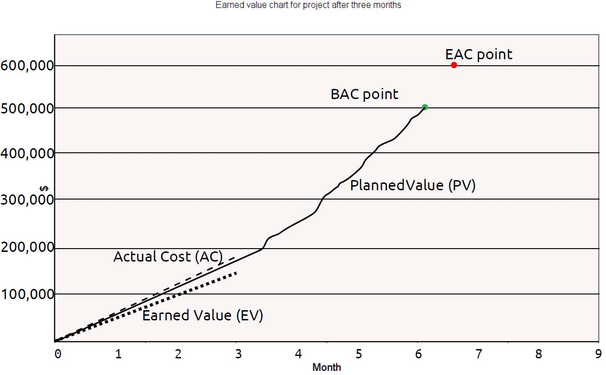

An EAC point above and to the right of the BAC point means the project is projected to cost more ($602,409) and take longer (6.38 months) than planned. The estimate at completion (EAC) is an estimated cost of completing this project based on performance to date. Budget at completion (BAC), the original total budget for the project, or $500,000 in this example. The BAC point is plotted on the chart at the original time estimate of 6 months. The chart includes three lines, as well: Planned value ($160,000), the cumulative planned amounts for all activities by month. The planned value line extends for the estimated length of six months and ends at the BAC point. Actual cost ($180,000) is the cumulative actual amounts for all activities in the first three months. Earned value ($150,000) is the cumulative earned value amounts for all activities by month.

2.c. As per provided information the project is late and over budget. However, it is not necessary to alert the project sponsor and ask for assistance because the cost estimates and the associated actual costs are not the same. In this case, tracking performance against assumed information produces misleading results.

# Appendix: Included .mpp file

## Microsoft Project file enclosed as a separate file.